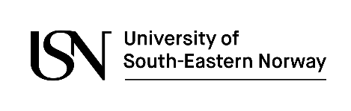
Master’s Thesis Declaration
Information and declaration concerning the student’s own work

Information
Master’s thesis title:
Name and student number:
Course code & title:
Study programme code & title:
Number of pages:
Course coordinator:
Supervisor(s):
Submission date:
Notes:
Accessibility: | Accessible to the public ⁭ or: Exempted from public access ⁭
Published: |  | YES | NO
Permission to publish the thesis on USN’s open research archive on the Web (USN Open Archive)?

Declaration
I / we hereby declare that this Master’s thesis is my/our own work, and it does not contain other people’s work without this being stated; and does not contain my / our previous work without this being stated, and that the bibliography contains all the literature that I/we have used in writing the thesis, and that all references refer to this bibliography.
I / we understand that any violation of these rules will be considered cheating and result in annulment of the examination and possible exclusion from all Norwegian universities and colleges, subject to the Regulations Concerning Examinations and Admission Rights at University of South-Eastern Norway § 8-8; see also the Act relating to Universities and University Colleges: §§4-7 and 4-8.

Date: Signature(s):

Approved by supervisor, date: Signature:

